What is Dependency Injection?
Dependency Injection is a design pattern where a class receives its dependencies from an external source rather than creating them itself.
👉 Angular uses DI to provide services to components.
Without DI
Car ,Engine
class Car {
engine = new Engine(); // tightly coupled
}
With DI
class Car {
constructor(public engine: Engine) {}
}
Angular automatically provides Engine.

DI in Angular
Angular has a built-in injector that creates and supplies dependencies.
Logger.service.ts
providedIn:root –angular creates single global instance (Singleton)
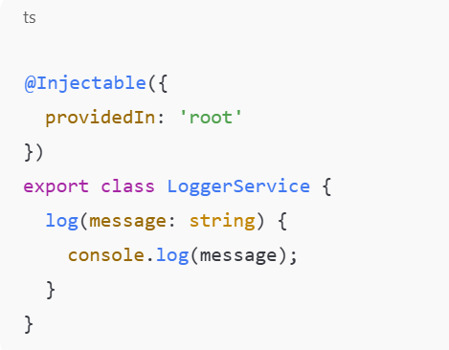

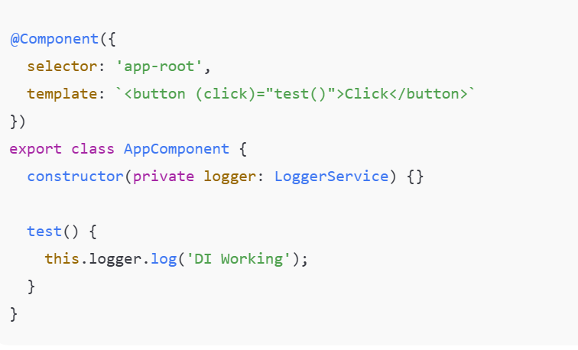
Angular automatically creates and injects service.

Injector Hierarchy
Angular injectors exist at multiple levels:
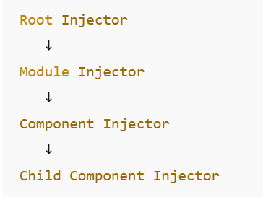

Angular has a tree like structure of injectors,similar to the component tree.
When a component request a service:
- Angular checks the component injector
- Then the parent component injector
- The module/root injector
- If not found ---error
---this is called hierarchial Dependency injection

DI Providers
Providers tell Angular how to create a dependency.
--how a dependency (service/value) is created and delivered by the injector

1️⃣ Class Provider
providers: [LoggerService]
LoggerService new LoggerService()

2️⃣ useClass
providers: [
{ provide: LoggerService, useClass: BetterLoggerService }
]

3️⃣ useValue
providers: [
{ provide: 'API_URL', useValue: 'https://api.example.com' }
]
Inject:
constructor(@Inject('API_URL') private url: string) {}

4️⃣ useFactory
export function loggerFactory() {
return new LoggerService();
}

providers: [
{ provide: LoggerService, useFactory: loggerFactory }
]

5️⃣ useExisting
providers: [
LoggerService,
{ provide: 'OLD_LOGGER', useExisting: LoggerService }
]

When to Use Each Provider
Provider | Use Case
useClass | Replace service
useValue | Constants/config
useExisting | Alias/compatibility
useFactory | Dynamic creation
InjectionToken | Non-class DI

Services in Angular
Services contain reusable business logic.
Creating Services
Generate
ng generate service user

